**Use Case Diagram**

**User Diagram for Patient**

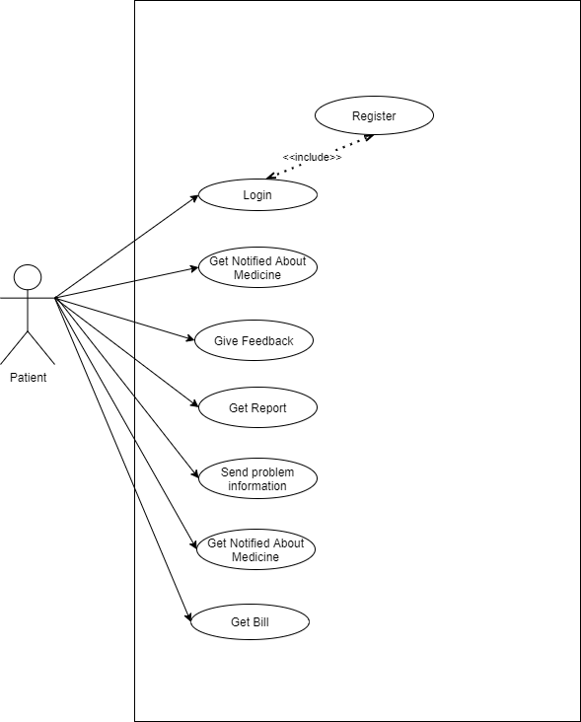

**Use Case Diagram for Doctor**

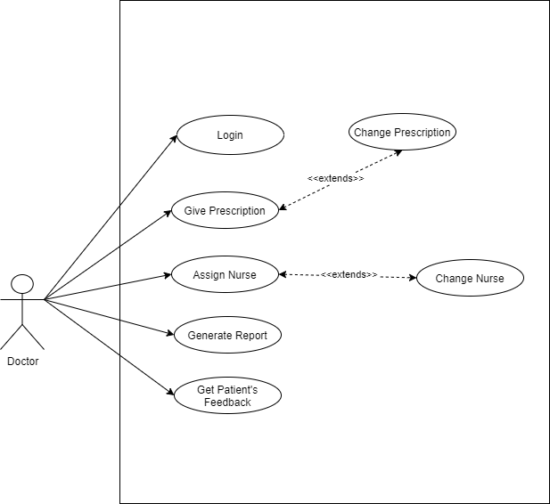

**Use case diagram for nurse**

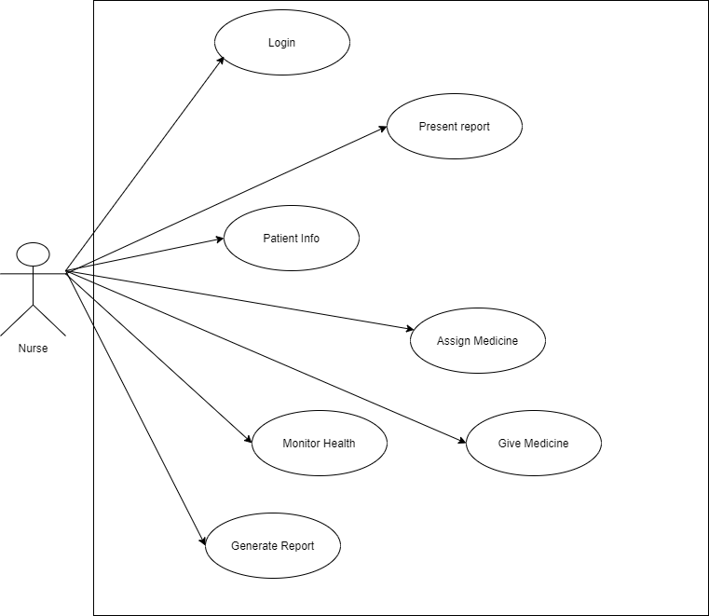

**Use case diagram for assistant**

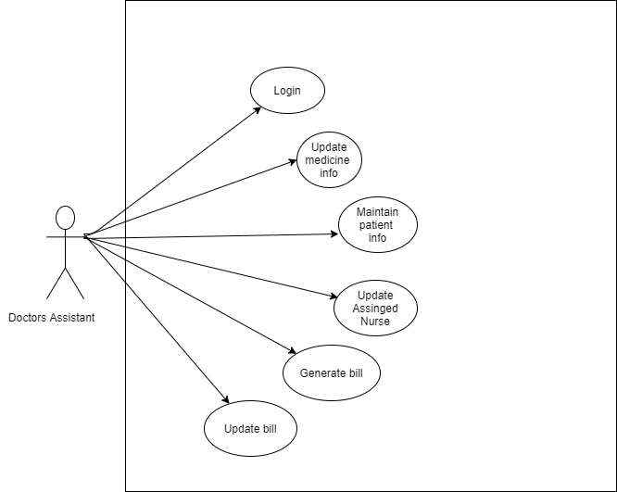

**Use Case diagram for admin**

